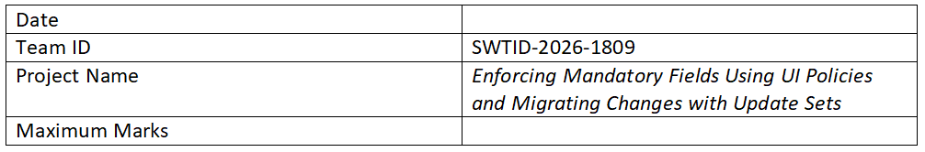
Solution Architecture

Project Title: Implementing Mandatory Field Validation Using UI Policies and Migrating Changes Through Update Sets

Solution Architecture:
Solution architecture is a structured approach that bridges the gap between business requirements and technical implementation. In this project, the architecture focuses on enforcing mandatory fields using UI Policies and managing system changes using Update Sets.
The primary goal is to ensure data integrity by making specific fields mandatory based on defined conditions using UI Policies. These policies help control form behavior dynamically without extensive scripting.
Additionally, Update Sets are used to capture, track, and migrate configuration changes from one instance to another. This ensures smooth deployment and consistency across development, testing, and production environments.
The solution defines the structure, features, and implementation process, including creating UI Policies, configuring mandatory fields, testing functionality, and migrating changes using Update Sets.
Overall, this architecture provides a reliable and efficient method to enforce field validation and manage system updates effectively.

